ConsoleCommon

**Summary**

ConsoleCommon provides a set of helper tools intended for use with console applications. These tools focus on automating argument typing and validation, and creating help text. To better understand what these tools do, consider the following scenario.

A programmer creates a console application that searches a database for a specific customer. The console application requires the following arguments: first name, last name and date of birth. In order to call the console application, a user would type something like the following at the command line:

CustomerFinder.exe Yisrael Lax 11-28-1987

In the code, the application would first have to parse the user’s input arguments. In a robust design, the application would then create a customer object that has a first name, last name, and date of birth property. It would then set each of these properties to the values passed in from the user. Several issues arise immediately. The first is that the application would have to require the user to pass in each argument in a pre-set order (first name then last name then date of birth, in our example). Next, to be robust, the application would do some type validation prior to setting fields on the new customer object in order to avoid a type mismatch error. If the user, for example, passed in an invalid date, the application should know that before attempting to set the date field on the customer object and throw an appropriate error with a descriptive message to alert the user of what the issue it encountered was. Next, the application would conduct other validation checks. For example, let’s say that the application considers it invalid to pass in a date that is set for the future. Doing so then should cause an error.

The ConsoleCommon toolset solves all of these issues through automatic typing and error validation. In addition, ConsoleCommon also provides some automatic help text generation. A good console application should always come packaged with good help text which should typically be displayed to the user upon typing something like the following:

CustomerFinder.exe /?

This help text is often annoying to create, properly format, and maintain. ConsoleCommon makes this easy, as you will see soon.

**Basic Implementation Example**

ConsoleCommon works by implementing the abstract ParamsObject class. This class will contain strongly typed properties that represent the input arguments for the application. These properties are created on the fly and, in order to indicate to the ConsoleCommon library that these are arguments, they must be decorated with the Switch attribute. For the CustomerFinder.exe application, we will implement a CustomerParamsObject. First, reference the ConsoleCommon .dll and create a using statement for ConsoleCommon. Then, implement the class and create some basic switch properties:

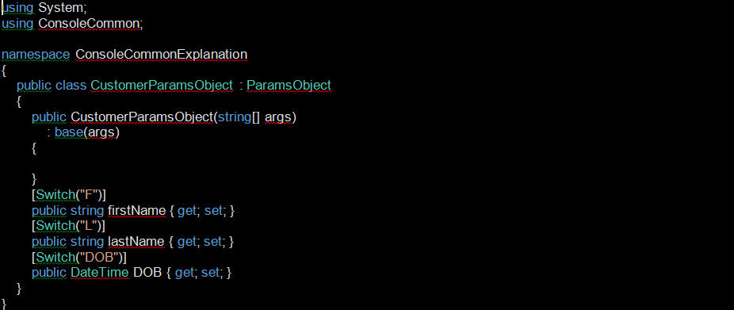

The string values in the Switch attributes (“F”, “L”, and “DOB”) specify how the application requires the user to pass in arguments. Rather than specifying that the user must pass in arguments in a specific order, ConsoleCommon has users pass in arguments using switches, in any order, such as in the following example:

CustomerFinder.exe /F:Yisrael /DOB:11-28-1987 /L:Lax

Each “switch” is an argument combined with a switch name. Users specify switches using the format /[SwitchName]:[Argument]. In the above example, “/F:Yisrael” is a single switch. ConsoleCommon will then search the input arguments for switch values that align with switch properties defined on CustomerParamsObject, it will then do type checking, execute some automatic validation, and, if everything passes, set the switch properties on the CustomerParamsObject to the input arguments. To consume the CustomerParamsObject, our client will look like this:

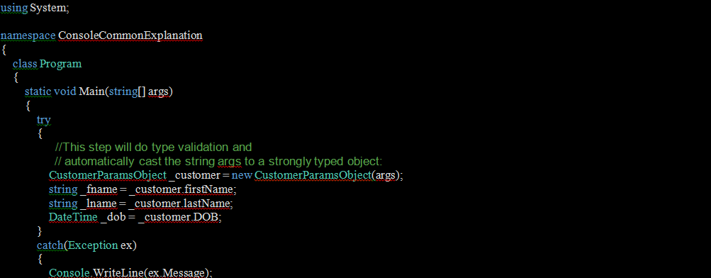

Always wrap the instantiation of the ParamsObject in a try… catch because if there is a type mismatch (for example, the user passed in an invalid date for the “DOB” switch), an error will be thrown describing the issue.

**Additional Validation**

Aside from type checking, additional validation is available on the ParamsObject.

Required

A switch property can be marked as “required” or “optional” by passing in an additional parameter into the property’s SwitchAttribute constructor. By default, switches are not required. In the following example, “firstName”, and “lastName” are required and “DOB” is optional:

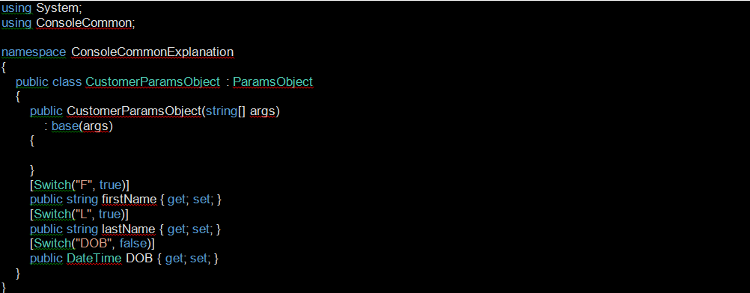

Users now can choose whether or not to pass in a date of birth, but must pass in, at the minimum, a first name and last name. In order to cause ConsoleCommon to check for required fields and other types of validation checks that we will cover soon, use the following command:



Always wrap the CheckParams() call in a try… catch because any validation error causes a descriptive exception to be thrown.

Restricted Value Set

To restrict the set of values a single argument can be set to, set the “switchValues” constructer argument in the SwitchAttribute to a list of values. For example, say you only want to allow users to search for people with the last name “Smith”, “Johnson”, or “Nixon”. Modify the CustomerParamsObject to look like this:

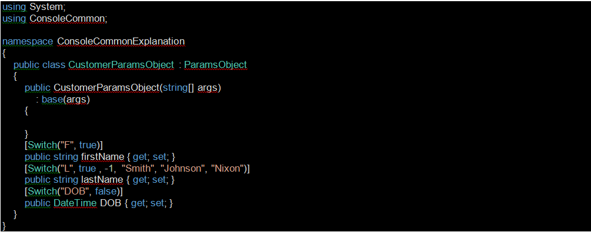

Note the modified SwitchAttribute on the lastName property. If the customer passes in a last name other than one in the restricted list defined above, ConsoleCommon will throw an error as soon as CheckParams() is called. The ‘-1’ value is used to set the default ordinal value to its default value so ConsoleCommon ignores it. We will explain default ordinals later.

Another way to establish a restricted list is to use an enum type for your switch property. ConsoleCommon will automatically restrict the value set of the enum property to the names of the enum’s values. Notice that, in the below example, we’ve created a new enum LastNameEnum and changed the type of the lastName property from string to LastNameEnum:

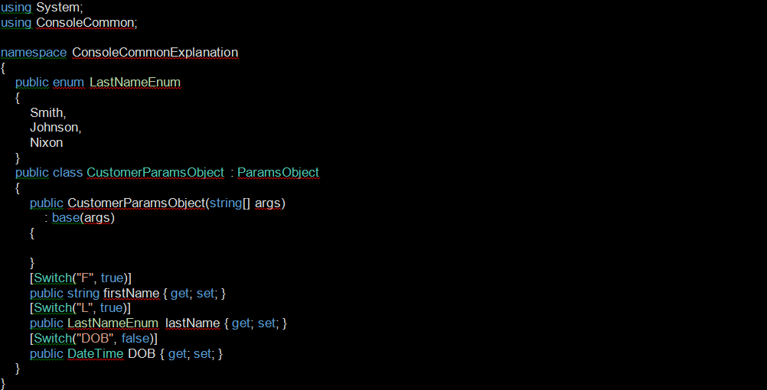

Custom Validation

If additional validation is needed aside from the built-in validation, you can implement the GetParamExceptionDictionary() method on the ParamsObject implementation. This allows you to add additional validation checks that are called when CheckParams() is called. This method requires a Dictionary to be returned. Each entry in this Dictionary contains a Func<bool> which contains a validation check, paired with a string containing an exception message to be returned in the case that the validation check fails. Func’s are used for their delayed processing feature. When CheckParams() is called, ConsoleCommon iterates through the Dictionary returned from the GetParamExceptionDictionary() method, processes each Func<bool>, and, if any are false, throws an error with the Func’s paired string message as the exception message. In the below example, we’ve added an exception check that ensures a user does not pass in a future date for the date of birth field:

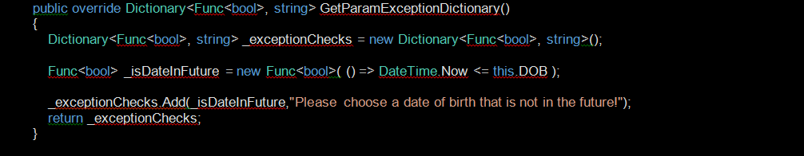

If the user does do so, when CheckParams() is called, an exception with the message “Please choose a date of birth that is not in the future!” will be returned to the caller.

**Automatic Help Text Generation**

The user triggers printing out of help text by passing “/?”, “/help” or “help” as the first argument into the application:

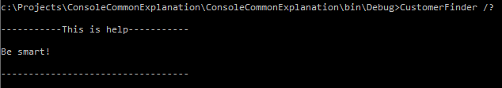

The most basic way to implement help text generation is by overriding the GetHelp() method on the ParamsObject implementation, in our case, the CustomerParamsObject:

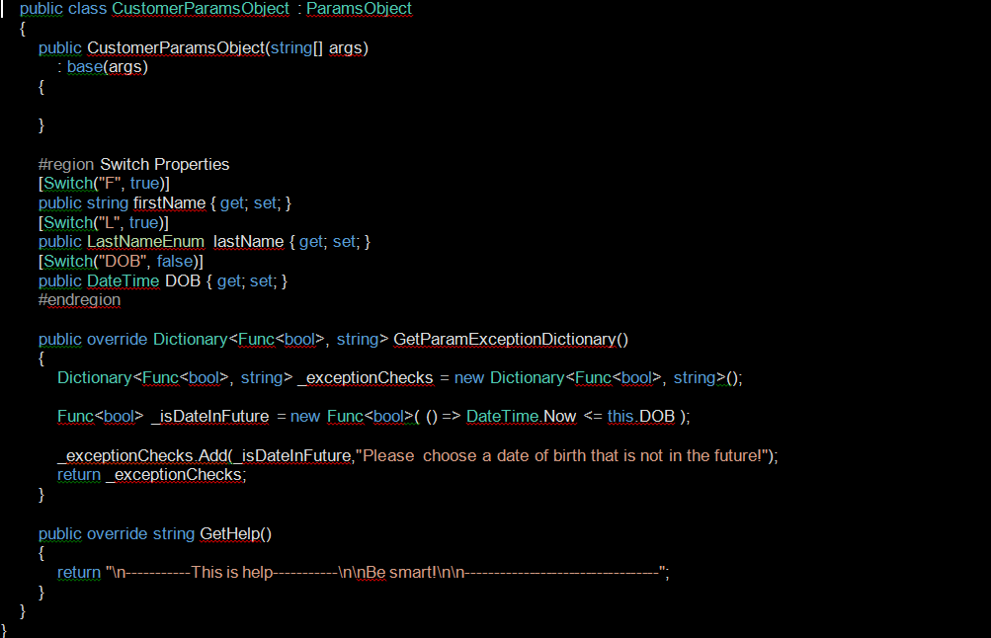

Then, the client would call the GetHelp() like this:

//CustomerParamsObject _customer = new CustomerParamsObject(args)

String _helptext = _customer.GetHelp();

Console.Writeline(_helptext);

However, this approach doesn’t take advantage of ConsoleCommon’s more automatic features surrounding help text generation.

Help Text Properties

ConsoleCommon provides some automatic formatting features to assist in creating help text. To take advantage of these, do not override the GetHelp() method. Rather, create string properties on the ParamsObject implementation and decorate them with the HelpTextAttribute. These properties return a single help text component. Note the new Description and ExampleText help text properties, below:



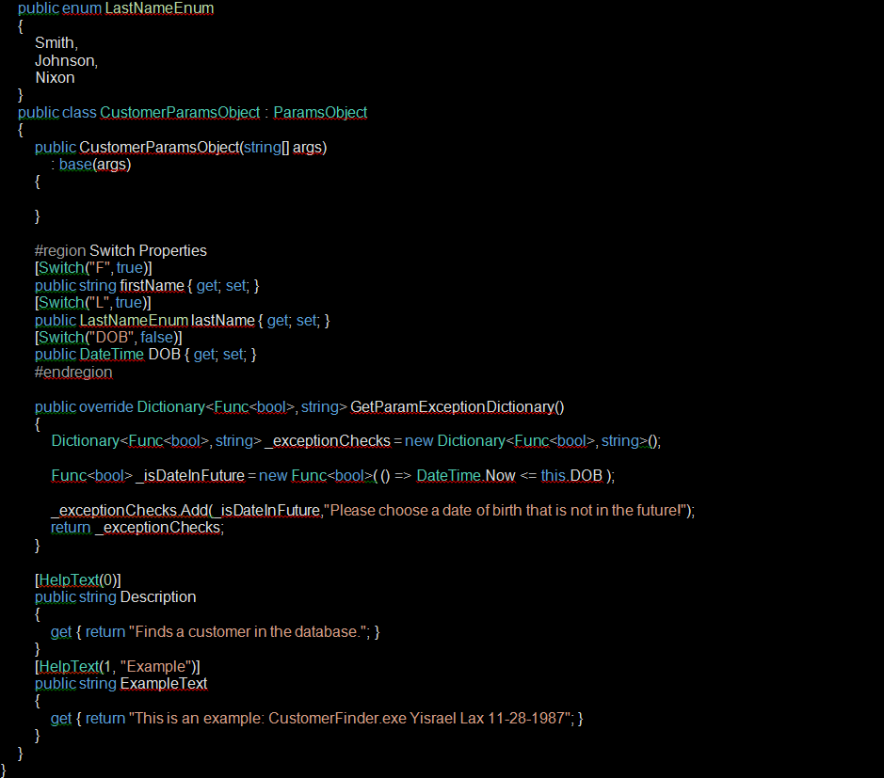

The HelpTextAttribute’s constructor must specify an ordinal value, which determines where that help text component appears when the user requests help. By default, the help text component is preceded with the name of the property and a colon. However, the help text component’s name can be overridden by specifying a name in the HelpTextAttribute’s constructor. The Description property above uses the property name and the ExampleText property overrides this default behavior and, instead, uses the name “Example”. The result can be seen below:

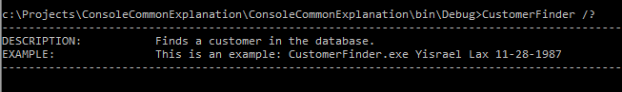

Included Help Text Properties

There are several included help text properties that you can use if you choose to. These are the Usage property and the SwitchHelp property. To use either of these, override them, decorate them with a HelpTextAttribute just like you would with any other help text property, but return the base’s implementation of the property instead of a custom implementation:



Usage Property

This help text property will print out an example of how to call the application:



SwitchHelp Property

This help text property prints out help text for each switch property/argument and requires additional work before it will print out anything meaningful. To implement this, decorate each of the switch properties with a SwitchHelpTextAttribute and pass in to the attribute’s constructor some basic help text for that switch property. In the following example, note the new attributes decorating the switch properties and the new Description and Usage properties:

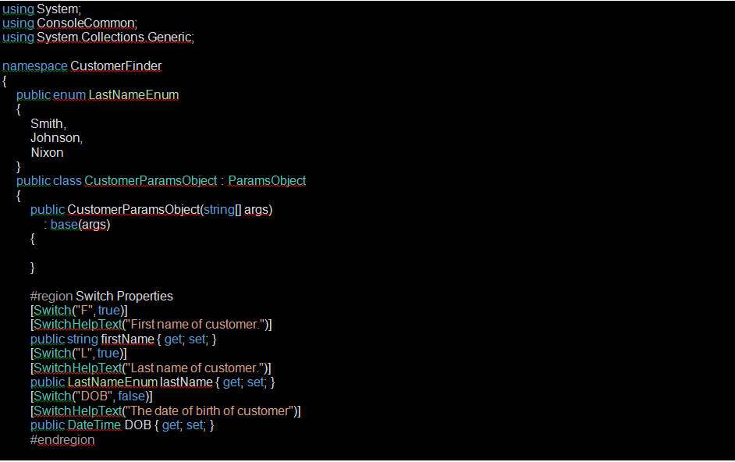

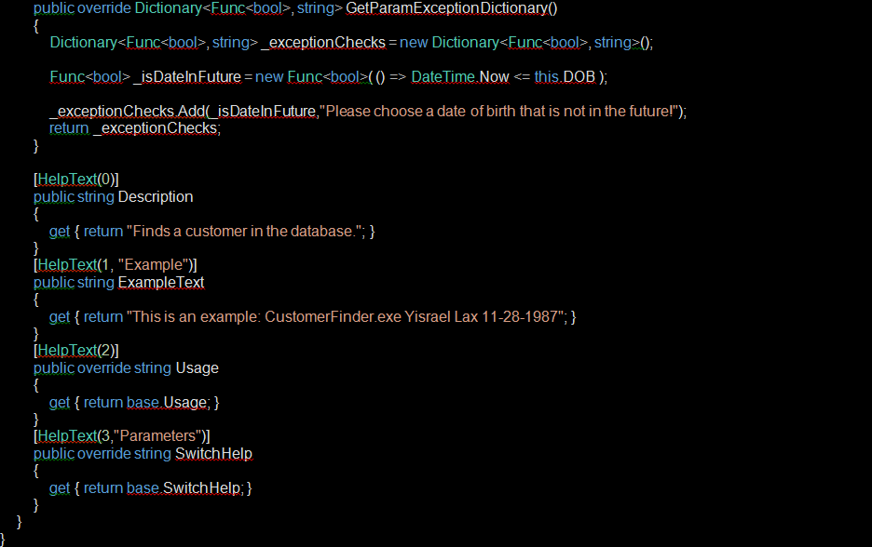

And, the output is:

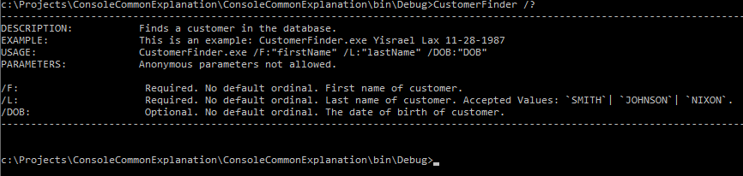

As you can tell, the SwitchHelp help text property provides quite a bit of information that you did not specify explicitly including whether or not the argument is required, if there is a default ordinal, and a list of allowed values for that property.

Getting Help If Needed

In most cases, you only want to print out help to the console if the user requested it. To do this, use the GetHelpIfNeeded() method, which returns a string containing the help text if the user passed in a help switch (“/?”, “/help”, or “help”) as the first argument, or a string.Empty if the user did not. A simple implementation looks like this:

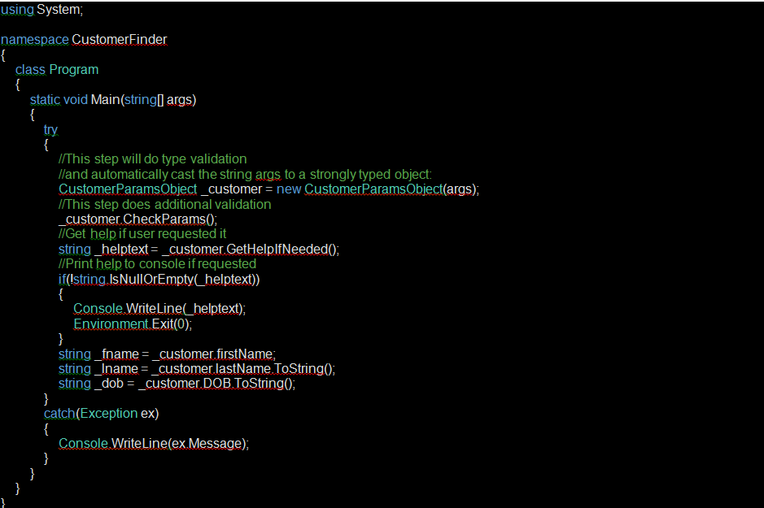

**Default Ordinal**

Default ordinals are parameters that can be specified for switch properties that allow your console application to be called with ordered arguments rather than switches. This feature allows for backwards compatibility in cases where ConsoleCommon is being implemented for a console application that is already built and has external batch scripts and applications currently calling it with non-switched ordered arguments such as:

CustomerFinder.exe Yisrael Lax 11-28-1987

To allow for this implementation, add an ordinal value in each switch property’s SwitchAttribute:



You’ll notice that the help text has changed as well. It now lists switch properties in order of their default ordinals as well has some additional messaging surrounding default ordinals.

Default ordinals can get complicated because calling the application with a mix of arguments using default ordinals and arguments using switches is allowed. Making things even more complicated, it is perfectly allowable to have some switch properties that have a default ordinal, and some properties that do not. There is some complex logic that determines specific requirements when doing any mixing and matching, which we won’t go into detail here. However, much of it is intuitive and, playing around with mixing and matching can help you determine this logic on your own.

**Using Type Type Switch Properties**

This is not a typo. Switch properties can be made to be any type. However, types that are specifically supported include all primitive types, DateTimes, enums, Types, System.Security.SecureStrings, and any type that implements IConvertible. All other types will use the type’s default ToString() method to attempt to match an argument to the property’s value. This may result in erroneous data or unexpected exceptions being thrown.

Type type’s have a specific implementation. The idea of using a Type type is so that a user can specify any type that is in any of the assemblies associated with the application by name or by a descriptor specified in a certain type of attribute decorating the type. For example, say we have two classes:

class PizzaShopCustomer{ }

class BodegaCustomer { }

Now, on our ParamsObject implementation, we add a new property “CustomerType”:

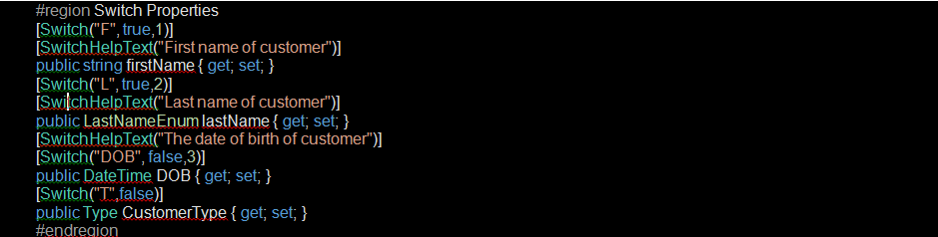

The user now has the ability to specify the type of Customer class with the /T switch:

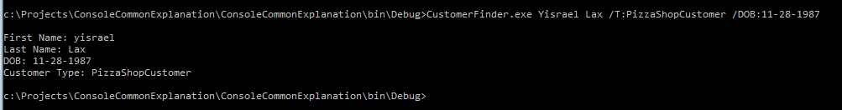

(Note that we used a mix of switches and default ordinals in the above example. We also added “Lax” to the LastNameEnum). There is one annoying aspect of this implementation, though: in our application example, the user is required to input the name of a class, which isn’t necessarily user friendly (the user, for example, might not be able to figure out why they have to type the word “customer” at the end of the customer type). To work around this, the class can be decorated with a ConsoleCommon.TypeParamAttribute that specifies a friendly name:

[TypeParam("pizza shop")]

public class PizzaShopCustomer { }

[TypeParam("bodega")]

public class BodegaCustomer { }

Now, the user can use the friendly names specified above when calling the application:

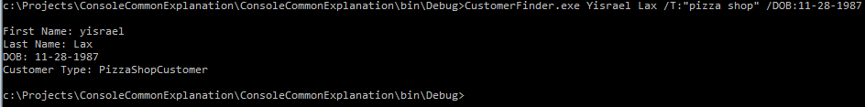

Using a Type type switch property is most useful when used in conjunction with restricted values feature. When doing it that way, this property then becomes quite useful to be used together with a factory class.

**Full Example Code**

